Exercise 5: Tables & Layouts

Jatin Chowdhary

Lab Section #03

Wednesday, November 22nd, 2017

Michele Tsang

1. 140 features comprise HamCT

2. The coordinate system of HamCT is: NAD_1983_UTM_Zone_17N

3. In HamCT’s attribute table, CTUID serves as the foreign key in the join

4. In HealthData, CTUID serves as the primary key in the join

5. It’s a one-to-one relationship, where one tuple in HealthData represents one tuple in HamCT, and vice versa.

6.

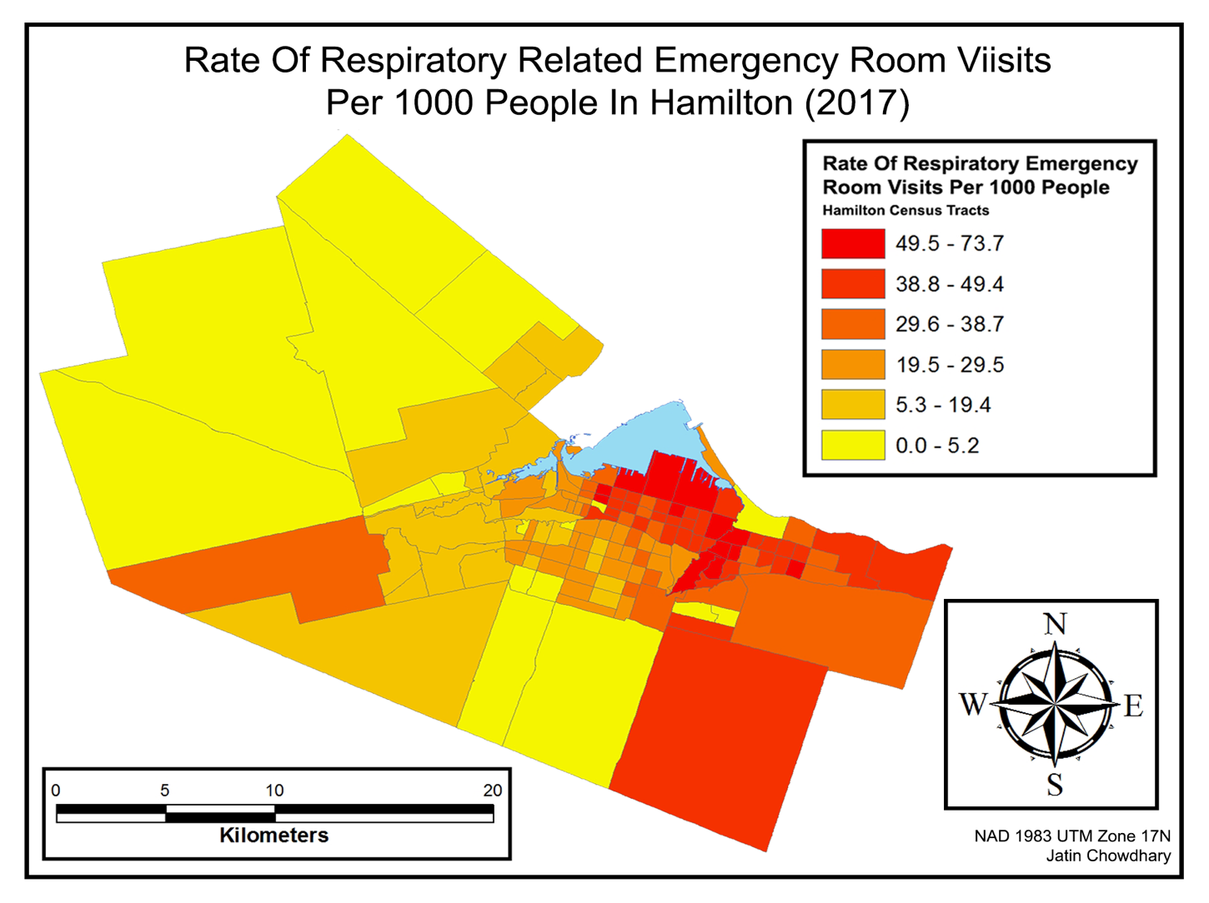

7. I choose Natural Breaks to classify RDRt1000. I chose it because it considers underlying data by minimizing the differences in data values in the same class and maximizes differences between classes, via a computer algorithm. This kind of classification is great for policy makers and governments, because it visually allows them to see where people need access to healthcare, and thus allowing them to strategically build hospitals/ERs. The map visually displays that a lot of respiratory emergency visits occur from tracts near South and East of the water bodies in Hamilton – and very few from North-West of Hamilton.